Heidelberg DWL66fs
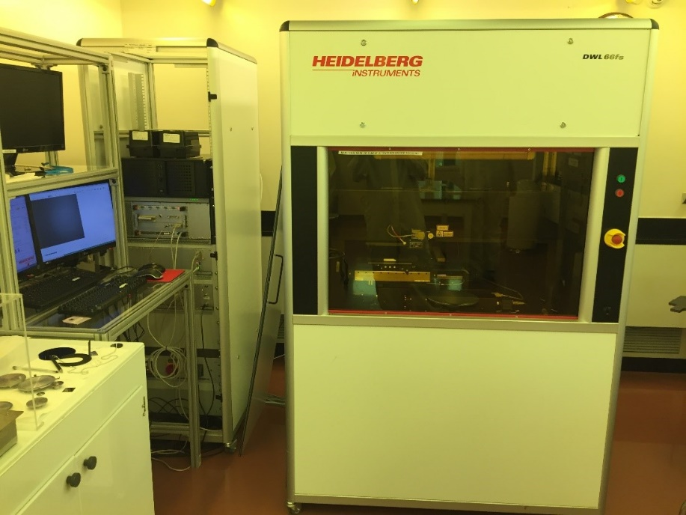
The DWL66fs laser lithography system is an economical, high resolution pattern generator for mask making and direct writing. It is useful in Advanced Packaging, MEMS, Micro-Optics, semiconductor, and other applications that require microstructures. It is equipped with alignment cameras for front only or front-to-backside alignment and can write a 2 µm line width with a 4 mm write head. The DWL66fs system consists of a Windows 7-based PC for running job files, a Linux-based PC for CAD file conversion, and the main system unit itself. The tool accepts files of various formats, but for best results, the standard GDSII format is recommended. The free CAD editor known as K-Layout can be downloaded and used to convert other file types to GDSII format. After passing the NCF safety exam, users can request training on this machine by sending an email to ncftech@uic.edu. Those not trained can request an NCF work service order by contacting the lab manager.
Location: cleanroom, lithography bay
Training: 3 sessions (2 trainings and a checkout session)
Technical Specifications | Acceptable mask sizes |  | Acceptable wafer sizes
Available Write head: 4mm  Minimum Line Width: 2 µm  Mask type: Chrome, Iron Oxide  Max Laser Power: 50 mW  CAD File types: GDSII (recommended), CIF |  | Thickness |  | Thickness
 | 4 x 4 inches  (100 mm X 100 mm) | 0.6 mm (600 µm) | 3 inches  (75 mm) | 0.5 mm (500 µm)
 | 5 x 5 inches  (125 mm X 125 mm) |  | 4 inches  (100 mm)
 | 6 x 6 inches  (150 mm X 150 mm) |  | Smaller chips must be larger than 30 mm

