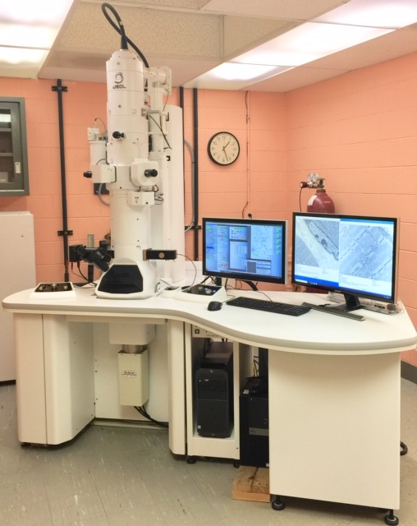
The JEOL JEM 1400 Flash TEM is a versatile 120kV Transmission Electron Microscope (TEM) which offers a wide range of applications and can be easily optimized for users’ research purposes. It is known for its ease of use with a multi-touch screen to provide high resolution imaging and analysis for a variety of interests, such as biologicals, polymers, nanotechnology, quality control, and advanced materials development.
Our scope is equipped with a LaB6 emitter gun (optimized for high contrast imaging for biological, low Z, and materials science application); and, 2 high-resolution AMT (12 Megapixel CCD and high-sensitivity sCMos) cameras to cover the broadest range of magnifications that may be needed, from ultra-low X10 full grid view to X 1.2 million total EM magnification. Easy to use camera software provides high resolution/high contrast imaging with very low readout noise.
(optional) The modular versatility of this J1400 Flash TEM allows for future expansion into tomography and other hot areas of visual and analytical research interest.

